Task – Travel from one concept to another concept wrt a student considering his learning.

Some new functions are created in the KG code from last week to complete the task, Explanation of functions –

get_paths_util: - it was used as helping function for the function below.

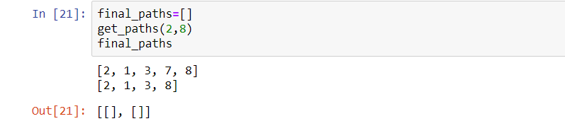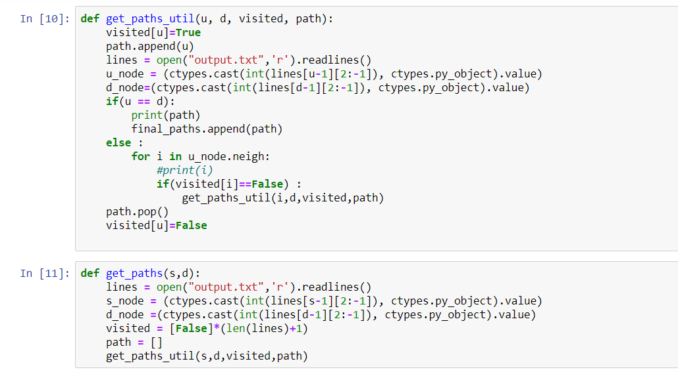get_paths :- this function was used to get all the possible paths from one node to another, initially we took the keys of the start_node and the target_node in the argument, and then from the existing output file we took the node details, and then used an algorithm to get all the possible paths from start_node to end_node, and in the code all the keys of the nodes in the paths were printed.

One problem that was faced in this was that we could not store the paths in an array, as it was a recursive kind of process and couldn’t use the return function due to some restrictions.

And now as we got the possible paths now its time to decide the optimal path that a student with particular skill set should follow to learn faster

For that we implemented the function

Traverse_update:- this function took the path, student ability and the threshold as the arguments, and now we need to travel along the path and decide which concepts to be learned and which can be skipped. So for that as we move to the next node from the start node towards the target node, if the skill matrix for that concept is greater than the students ability and their difference is also greater than a threshold then the student can’t skip this concept as there is some learning gap, so he should learn this concept, after he learnt that concept his ability is increased by alpha*(concept skill matrix - student ability), and only the increment in the ability of student was carried out and then the student moves ahead in a similar process till he reaches the target concept.

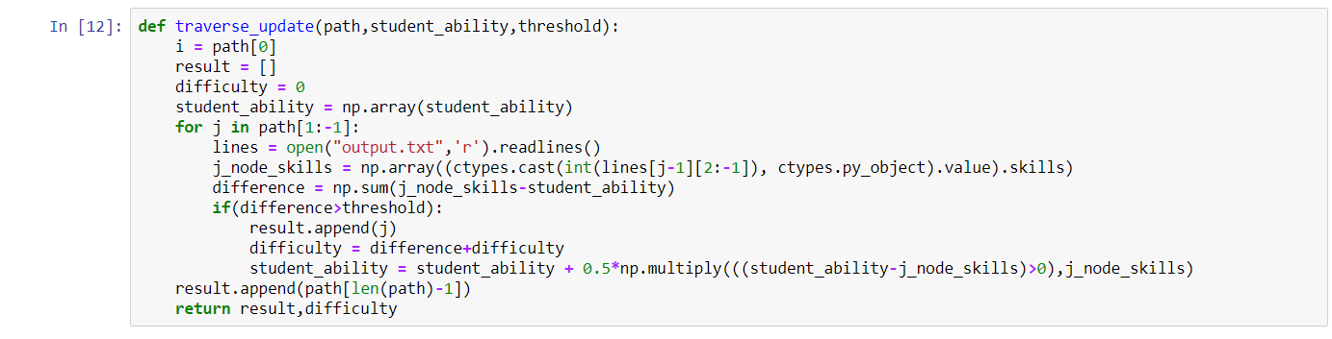So this function finally returns the “result” that is the array of the concepts he need to learn to reach the target, and also a constant “difficulty” which is dependent on the concepts he need to lean during the journey, we can use the length of result array and the difficulty as the metric to decide among the various paths, and hence in this way we can get the final path that a student should follow to reach the target concept.